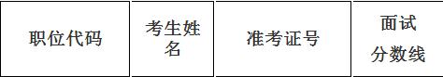
200110004014 | 孟 凡 | 123161106607 | 125.2
200110005022 | 陈俊英 | 123137654615 | 128.6
200110006017 | 廖凯举 | 123111511406 | 115.5
 | 郭强之 | 123137060716
200110007008 | 李 岩 | 123137656518 | 119.0
200110007009 | 叶丽娜 | 123111341210 | 124.7
200110011008 | 张 阳 | 123111751621 | 132.0
200110012005 | 邓文锴 | 123139040629 | 125.8
200110014005 | 艾婷婷 | 123111952303 | 135.1

